Paste all columns from SBAnational2_02 to the SBAnational2_01 columns:

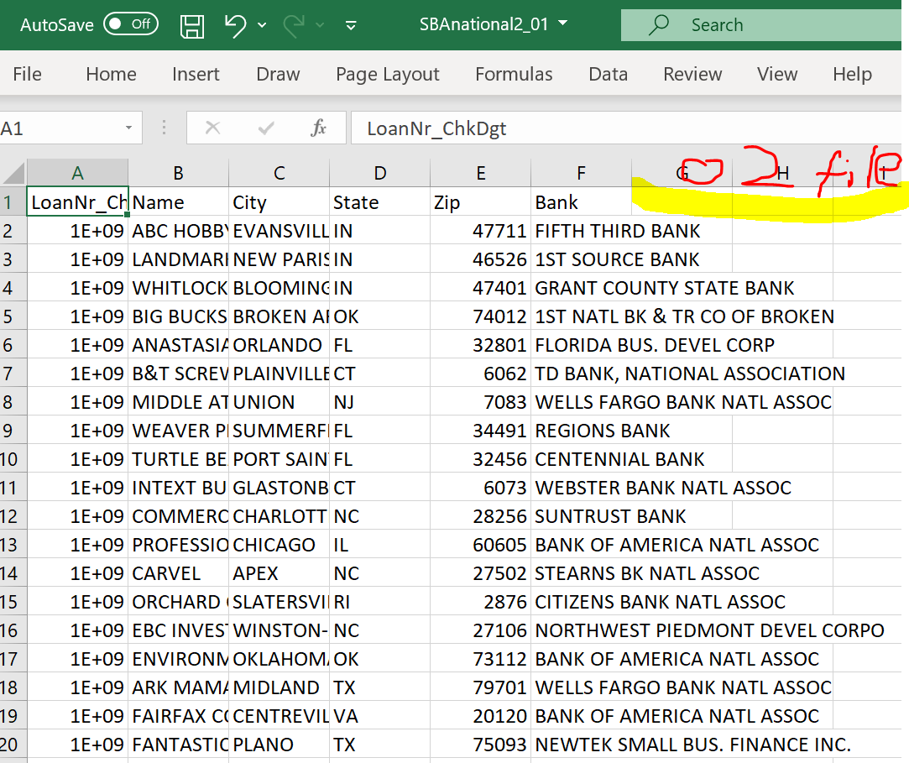

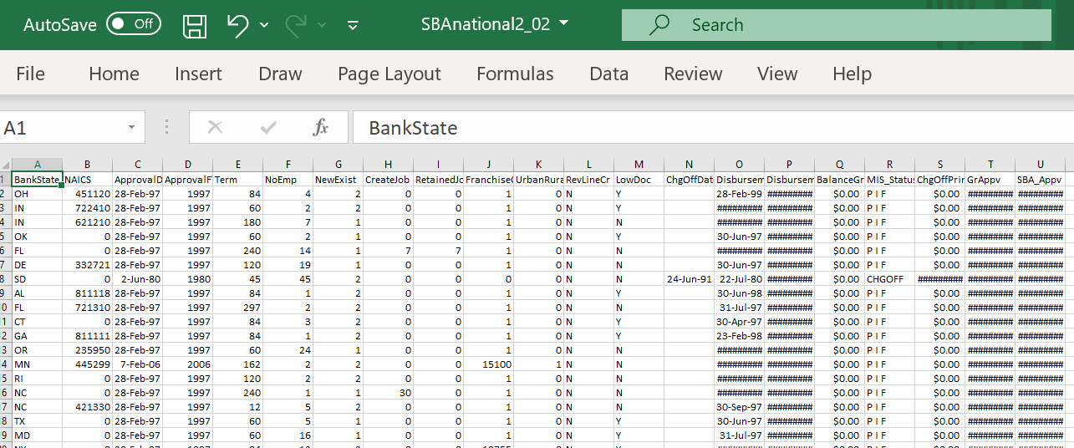

Final result:

